Curried Jazz (MFP 1307)

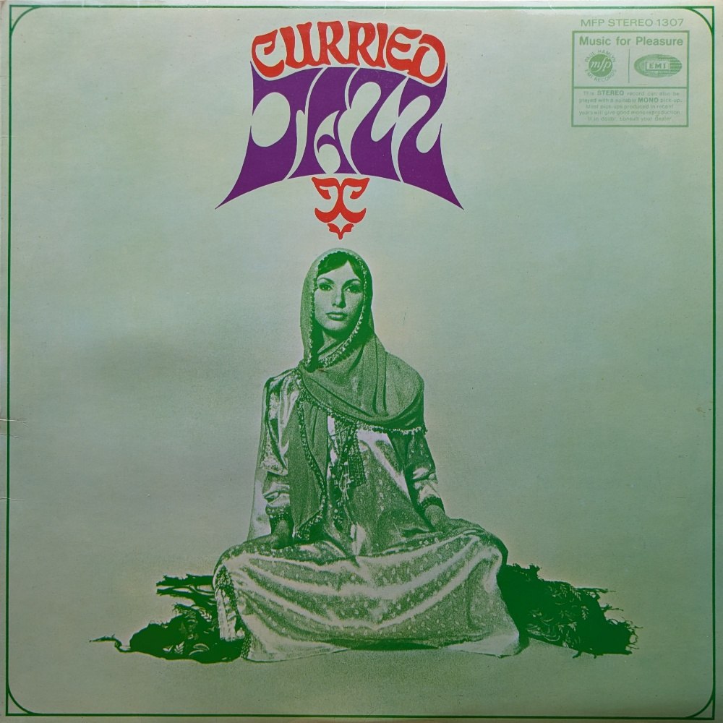
"Curried Jazz" is a very strange album. The budget label is moving into the creation of new and experimental recording. The record documents a unique attempt to bring together Indian classical music and jazz, two improvisational traditions that are structurally quite different.

Bandleader Ken Burgess noted, Indian classical improvisation unfolds against a drone and uses fluid timing, which is opposite to jazz's reliance on fixed chord sequences and counted bars. The challenge in the recording was about defining a structure that both sets of musicians could adhere to.

Arranger Victor Graham was brought in to create written parts that made the Indian drone patterns look like familiar chord charts for the jazz musicians, while leaving enough freedom for the Indian players. The result is a sort of separated coexistence of both genres of music; but without it sounding as if the players are in different rooms not really listening to one another.

The group was assembled informally, sitarist Dev Kumar, for example, was found through a chain of phone calls. The line-up was modest. In total just seven jazz and four Indian musicians were involved in the music on the project. Even though a 1969 Melody Maker column recommended "Curried Jazz" framing it as serious listening, it still would have been a kind of novelty record. One contemporary review used a rather naff analogy “It’s strictly korma rather than vindaloo, but like good Indian food, it’s cheap!”

Ken Burgess reported that it sold 15,000 copies in its first month, even though MFP thought it wouldn't sell.

